**PARTICPIPANT INFORMATION LEAFLET for CHILDREN (aged 8-12 years)**

|  |  |
| --- | --- |
| **Study Title:** | “Molecular and Genomic Interrogation of Childhood Cancer – Ireland” (MAGIC-I) |
| **Participant Name:** |  |

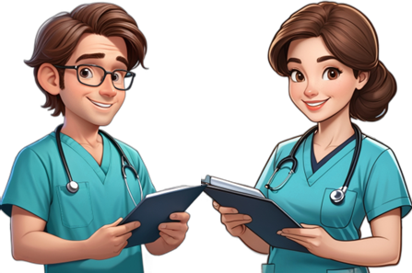

Hello!

We would like to ask for your help with an exciting new research project!

In this information leaflet, we would like to explain this project, and what is involved if you decide to take part. Please ask your parents or your doctors if there are any words that you do not understand.

**What is this project about?**

We are trying to learn how and why children like you sometimes get sick with cancer.

**What do I have to do to help with this project?**

If you decide to take part in this project, we will firstly collect some information about you and your cancer.

When your doctors are doing blood tests from your ‘Freddy’ as part of looking after you, we would like to take an extra blood sample to help us learn more about your cancer – you do not have to have any extra needles to help us with our project.

If you are going to sleep (having an anaesthetic) for tests on your bone marrow or on your tumour as part of your cancer treatment, we would also like to take an extra sample of bone marrow and/or a tiny piece of your skin and/or a tiny piece of your tumour to help us with our project. You do not have to have any extra anaesthetics to help us with our project.

**What happens with my information and my blood/bone marrow/skin/tumour samples?**

Information about you and your cancer will be kept private and safe with the project team.

Any samples that we take from you as part of this project will be tested by our scientist friends in the University College Dublin (UCD). We are doing this so we can try to understand how and why children get sick with cancer. We will use the results to see if we can design better medicines to help children get better.

**Do I have to help with this project?**

We want you to know that you do not have to take part in this study if you don’t want to, and if you decide not to, it will not change your medicines (treatment) in any way.

**What else do I need to know?**

An important part of a research project like ours is that we share the results with other doctors and scientists around the world, so that we can learn from each other and help more children like you. To share our results, we write about the study and talk to other experts around the world. When we do this, we do not share your name or where you are from, so that your information will always remain private and safe.

**What if I change my mind?**

You can change your mind at any time. If you decide that you don’t want to be in the study at any time, you just need to tell your parents and/or your doctor. Changing your mind will not affect how your doctors look after you.

**What happens next?**

Ask your parents or your doctors if you would like any more information about this study.

If you would like to take part in this project, you and your parents will be asked to sign a form that tells us that you agree to be part of this study, and the doctors and the study team will do the rest!

**Thank you for taking the time to read this information and for helping us with our project!**